

Learn with Brainmine
WHAT’S INSIDE?

- Digital Marketing
- SEO (Search Engine Optimization)
- On Page Optimization
- Off Page Optimization
- Technical SEO
- Semrush
- Google Analytics
- Google Search Console

Let’s Begin with Digital Marketing


Digital marketing refers to the use of digital channels and technologies to promote products, services, or brands to a target audience. It involves various online strategies and tactics to reach potential customers, engage with them, and convert them into loyal clients. Digital marketing offers a more cost-effective and measurable approach compared to traditional marketing methods.

Example of Digital Marketing for a Tattoo Shop:

Let's say there's a local tattoo shop called "Ink Master Studio," and they want to boost their business through digital marketing. Here are some strategies they could employ:

Website Creation and Optimization: Ink Master Studio should have a user-friendly and visually appealing website that showcases their portfolio, information about the artists, services offered, contact details, and a blog section to share informative content about tattoos, aftercare, and industry trends. The website should be mobile-friendly for better accessibility.

Search Engine Optimization (SEO): To ensure their website ranks higher on search engine results when people search for tattoo-related keywords like "best tattoo shop in [city]," Ink Master Studio should implement SEO techniques. This involves using relevant keywords, creating quality content, optimizing meta tags, and acquiring backlinks from reputable sources.

Social Media Marketing: The tattoo shop can create profiles on popular social media platforms such as Instagram, Facebook, and Twitter. They can post pictures and videos of their work, behind-the-scenes glimpses of the studio, client testimonials, and engage with followers by responding to comments and messages.

Paid Advertising (PPC): Ink Master Studio can run targeted pay-per-click (PPC) advertising campaigns on platforms like Google Ads or Facebook Ads. By bidding on specific keywords or demographics, they can ensure their ads appear to relevant audiences, driving potential customers to their website or landing pages.

Email Marketing: The shop can build an email list of interested customers and send out newsletters with updates, special offers, and promotions. Email marketing can help in nurturing customer relationships and encouraging repeat business.

Local Business Listings: Ink Master Studio should list their business on Google My Business and other online directories. This will improve their local visibility and provide essential information such as address, opening hours, and reviews.

Content Marketing: Creating valuable and informative content related to tattoos, tattoo care, and designs can attract potential clients and position Ink Master Studio as an authority in the industry. This content can be shared through blog posts, social media, or even YouTube videos.

Influencer Partnerships: Collaborating with local influencers or tattoo enthusiasts with a significant online following can widen the shop's reach and attract new customers.

Online Reviews and Testimonials: Encouraging satisfied customers to leave positive reviews on platforms like Google, Yelp, or Facebook can build trust and credibility for the tattoo shop.

Tracking and Analytics: Ink Master Studio should regularly monitor their digital marketing efforts using tools like Google Analytics to measure website traffic, user behavior, and conversion rates. This data can help them refine their strategies and optimize their campaigns for better results.

By implementing these digital marketing strategies, Ink Master Studio can effectively promote their tattoo services, increase their customer base, and establish a strong online presence in their local market.

Read more at: https://blog.hubspot.com/marketing/what-is-digital-marketing

SEO (Search Engine Optimization)


SEO, or Search Engine Optimization, is the process of improving a website's visibility and ranking on search engine results pages. The goal of SEO is to attract organic (non-paid) traffic to a website by optimizing its content, structure, and various elements to align with search engine algorithms. In the case of a tattoo shop, SEO can be essential to attract local customers and gain a competitive edge in the online market.

Example of SEO for a Tattoo Shop:

Let's consider a tattoo shop named "InkMaster Tattoos" located in New York City.

Keyword Research:

The first step in SEO is to conduct keyword research. Identify relevant keywords that potential customers might use to find a tattoo shop in NYC. For example, keywords like "tattoo shop NYC," "best tattoo artist New York," or "affordable tattoos in NYC" could be relevant.

Website Optimization:

Ensure that the website of "InkMaster Tattoos" is optimized for search engines. This includes:

- Including relevant keywords in the website's title, meta description, and headings.

- Creating unique and engaging content related to tattoos, aftercare tips, and the tattoo shop's specialties.

- Optimizing images with descriptive alt tags, as search engines also consider images.

Local SEO:

Since "InkMaster Tattoos" is a local business, it's essential to focus on local SEO to attract customers in New York City. Steps include:

Creating and verifying a Google My Business (GMB) listing, including accurate business information, contact details, and opening hours.
Getting positive reviews on GMB and other review platforms like Yelp, as they can influence local search rankings.

Backlinks and Citations:

Encourage other local businesses, tattoo artists, or relevant websites to link back to "InkMaster Tattoos'" website. These backlinks can improve the shop's authority in search engine rankings. Additionally, ensure consistent business citations across different online directories, including name, address, and phone number (NAP).

Mobile Optimization:

As many people use mobile devices to search for local businesses, it's crucial to have a mobile-friendly website. Google also considers mobile-friendliness as a ranking factor.

Social Media Presence:

Having an active presence on social media platforms like Instagram, Facebook, and Twitter can help drive traffic to the tattoo shop's website. Regularly posting about tattoo designs, events, and promotions can engage potential customers.

Content Marketing:

Consider starting a blog section on the website to regularly publish valuable and relevant content related to tattoos. This can attract potential customers and build authority in the tattoo industry.

Monitoring and Analytics:

Use tools like Google Analytics and Google Search Console to monitor website traffic, keyword performance, and user behavior. This data can help refine SEO strategies over time.

By implementing these SEO strategies, "InkMaster Tattoos" can increase its online visibility, attract more local customers searching for tattoo services in NYC, and potentially outrank competitors on search engine results pages. It's important to note that SEO is an ongoing process, and staying up-to-date with algorithm changes and customer trends is crucial for sustained success.

Read more at:
https://blog.hubspot.com/marketing/seo

On Page Optimization



On-Page Optimization is a set of techniques and practices used to improve the visibility and ranking of a website's pages in search engine results. It involves optimizing various elements on a webpage to make it more attractive and relevant to both search engines and users. Let's explore some On-Page Optimization strategies for a Tattoo Shop website, using examples:

Keyword Research and Usage:

Identify relevant keywords that potential customers might use to find a tattoo shop. For example, "tattoo shop," "tattoo artist," "tattoo studio," "custom tattoos," etc. Incorporate these keywords naturally into the website's content, such as the homepage, service pages, and blog posts.

Title Tags and Meta Descriptions:

Craft unique and compelling title tags and meta descriptions for each page. These should contain the target keywords and provide a concise and appealing summary of the page's content. For instance:

- Title Tag (Home Page): "Welcome to Ink Master: Your Premier Tattoo Shop in [City] for Custom Tattoos"

- Meta Description (Home Page): "Discover Ink Master - a leading tattoo studio in [City], where our talented artists create stunning custom tattoos that reflect your unique style and personality."

URL Structure:

Use descriptive URLs that include relevant keywords. For example:

www.inkmaster.com/custom-tattoos-[city]

Optimized Content:

Create high-quality and relevant content for the website's pages, blog, and gallery. Include informative articles about tattoo care, aftercare, popular tattoo designs, and trends. Each page should have a clear focus and use the targeted keywords naturally within the content.

Image Optimization:

Optimize images by using descriptive alt text and file names. For instance, if there's an image of a traditional Japanese dragon tattoo, the alt text and filename could be "traditional-japanese-dragon-tattoo.jpg." This helps search engines understand what the image is about and can also improve image search rankings.

Mobile-Friendly Design:

Ensure the website is responsive and displays well on various devices, including mobile phones and tablets. Google and other search engines prioritize mobile-friendly websites in their search results.

Internal Linking:

Establish a well-structured internal linking system to guide users to related content within the site. For example, on a page discussing tattoo styles, include links to pages showcasing specific tattoo style examples.

Page Loading Speed:

Optimize page loading speed by compressing images, using caching, and choosing a reliable hosting provider. A faster website provides a better user experience and can positively impact search engine rankings.

User Experience (UX) Improvements:

Focus on creating a user-friendly website with easy navigation, clear calls-to-action, and a visually appealing design. Positive user experiences can lead to longer dwell times and increased engagement, which can benefit search rankings.

Local SEO:

If the tattoo shop has a physical location, implement local SEO strategies such as adding the shop's name, address, and phone number (NAP) to the website's footer and contact page. Additionally, claim and optimize the Google My Business listing for the shop.

Remember, On-Page Optimization is just one aspect of SEO. Combining it with Off-Page Optimization (e.g., link building, social media engagement) and other marketing efforts will lead to a more comprehensive and successful digital marketing strategy for the tattoo shop.

Read more at:
https://www.searchenginejournal.com/on-page-seo

Off Page Optimization



Off-page optimization is a set of strategies and techniques used to improve the visibility, reputation, and authority of a website or webpage on search engine results pages (SERPs). Unlike on-page optimization, which involves optimizing elements on the website itself, off-page optimization focuses on factors that occur outside the website and impact its search engine rankings. These external factors are essential for search engines to determine the relevance and credibility of a website.

Example of Off-Page Optimization for a Tattoo Shop:

Let's consider a fictional tattoo shop called "InkMaster Tattoos" and explore some off-page optimization strategies they could employ to enhance their online presence and attract more customers.

Backlink Building:

InkMaster Tattoos could work on building high-quality backlinks from reputable websites related to tattoos, art, or local businesses. These backlinks act as "votes of confidence" from other websites, indicating that InkMaster Tattoos is a reliable and valuable source. For instance, they could collaborate with local art blogs or partner with other local businesses and get featured on their websites.

Social Media Marketing:

Creating and maintaining a strong presence on social media platforms can significantly boost visibility and engagement. InkMaster Tattoos can share high-quality images of their tattoo work, engage with their followers, and run contests or promotions to attract more people to their shop. Social media activity can also lead to user-generated content, where customers share their tattoo experiences, further promoting the shop.

Online Reviews and Local Directories:

Positive online reviews on platforms like Google My Business, Yelp, and Facebook can influence potential customers' decisions. InkMaster Tattoos should encourage satisfied clients to leave reviews, respond to reviews (both positive and negative), and ensure their business information is accurate and up-to-date on local directories.

Guest Blogging:

InkMaster Tattoos could collaborate with tattoo artists or enthusiasts to write guest blog posts for other tattoo-related websites. By providing valuable content and linking back to their website, they can gain exposure to a wider audience and strengthen their online authority.

Influencer Partnerships:

Partnering with influential tattoo artists or social media personalities can extend InkMaster Tattoos' reach to a larger audience. The influencers can showcase the shop's work or promote special events, attracting potential customers who follow the influencers.

Video Marketing:

Creating engaging tattoo-related videos and sharing them on platforms like YouTube can help build a loyal following. InkMaster Tattoos could showcase their artists at work, share tattoo aftercare tips, or provide insights into the tattoo industry, attracting viewers who might later become customers.

Local Events and Sponsorships:

Participating in local events and sponsoring tattoo-related gatherings can increase brand awareness and create a positive impression within the community. It helps position InkMaster Tattoos as an active and supportive member of the local tattoo community.

Remember, these off-page optimization strategies work best when combined with a solid on-page SEO foundation, quality content creation, and a commitment to providing excellent tattoo services. Over time, the implementation of these strategies should improve InkMaster Tattoos' online visibility and reputation, leading to increased organic traffic and potential business growth.

In SEO (Search Engine Optimization), backlinks can be categorized into several types based on their attributes and sources. Some common types of backlinks include:

- Natural Backlinks: These are links that are earned organically, without any direct effort from the website owner. They are typically generated when other websites find the content valuable and link to it voluntarily.

- Manual/Editorial Backlinks: These are backlinks that are acquired through deliberate outreach or by requesting other website owners, bloggers, or editors to link to your content.

- Guest Post Backlinks: These are links obtained by writing and publishing articles on other websites as a guest author, and including a link back to your own website in the author's bio or content.

- Web 2.0 Backlinks: These are links obtained from platforms that allow users to create and publish content, such as social media sites, blogging platforms, and article directories.

- Forum Backlinks: Links obtained by participating in online forums and including a link to your website in the forum signature or within the forum post (where relevant and allowed).

- Directory Backlinks: Links acquired by submitting website URLs to various online directories or business listing websites.

- Contextual Backlinks: These are links embedded within the content of a webpage and are typically considered more valuable than links placed in the sidebar or footer.

- DoFollow and NoFollow Backlinks: DoFollow backlinks pass on link authority from the source page to the linked page, while NoFollow backlinks indicate to search engines that they should not pass on link authority.

- Image Backlinks: Links obtained when other websites link to your website using an image instead of anchor text.

It's essential to focus on acquiring high-quality, relevant backlinks from authoritative sources as part of your SEO strategy. Quantity alone may not be as valuable as the relevance and authority of the linking sites. Search engines value natural and organic backlink profiles, and overusing certain types of backlinks (like PBNs) or engaging in manipulative practices can lead to negative SEO consequences.

Off Page Activities

"Yes, there are so many types of submissions that we can use in off-page SEO."

Off-Page activities
Web 2.0
Web 2.0 SB
Keyword Social Bookmarking
Classified
Profile Creation
Business Listing
Infographic Creation
Info Submission
Info SB
Video Creation
Video Submission
Video SB
PDF Creation
PDF Submissions
pdf sb
Forum Posting
Article Submission
Article Social Bookmarking
PR Submission
PR SB
Website Blog Post
Website Blog Social Bookmarking
LinkedIn Article
LinkedIN SB/Sharing
Map Citation
Quora
Blog Commenting
SEarch Eng Sub
Review
Google Post as SMO Posts
directory sub
image sub
FB group sharing
Ping sub
Total Submissions

Read more at:
https://www.semrush.com/blog/off-page-seo/

Technical SEO



Technical SEO refers to the process of optimizing a website to improve its search engine visibility and crawlability. It involves making various technical adjustments and enhancements to ensure that search engines can efficiently access, understand, and index the website's content. Technical SEO aims to enhance a site's overall performance, leading to higher search engine rankings and increased organic traffic.

Let's consider an example of a Tattoo Shop that wants to improve its online presence through technical SEO:

Website Structure and Navigation: The Tattoo Shop's website should have a clear and organized structure that allows both users and search engines to easily navigate through the content. Each tattoo category or service should have its dedicated page with relevant keywords in the URL, titles, and headings.

Example:

URL: www.tattooshop.com/tattoo-designs

- Title: Tattoo Designs - Best Tattoo Ideas | Tattoo Shop

- Mobile-Friendly Design: As a significant portion of web traffic comes from mobile devices, it's crucial for the Tattoo Shop's website to have a responsive design that adapts to different screen sizes. This ensures a positive user experience and can also improve search engine rankings, as Google prioritizes mobile-friendly websites.

- Page Speed Optimization: The website should load quickly to provide a better user experience and to meet Google's page speed ranking factor. Compressing images, leveraging browser caching, and minimizing server response time are some ways to achieve better page loading times.

- HTTPS and Security: The Tattoo Shop's website should use HTTPS to encrypt data and ensure a secure connection. This not only enhances user trust but is also considered a ranking signal by search engines.

- XML Sitemap: Creating an XML sitemap helps search engines discover and index all the important pages on the website. This ensures that new content or updates are promptly recognized by search engine crawlers.

- Robots.txt: Implementing a robots.txt file allows the Tattoo Shop to control which parts of the website are accessible to search engine crawlers. This file is useful for excluding non-essential pages or sensitive information from being indexed.

- Canonicalization: To prevent duplicate content issues, the Tattoo Shop's website should use canonical tags to specify the preferred version of a page when multiple versions with similar content exist.

Example:

Html Code

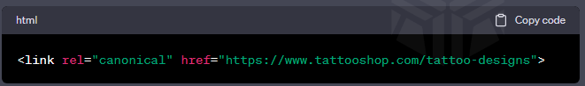

Schema Markup: Adding structured data using schema markup can enhance the visibility of the Tattoo Shop's website in search engine results. It provides additional information to search engines, enabling rich snippets and improving the website's chances of being featured in featured snippets.
Example:

Html Code

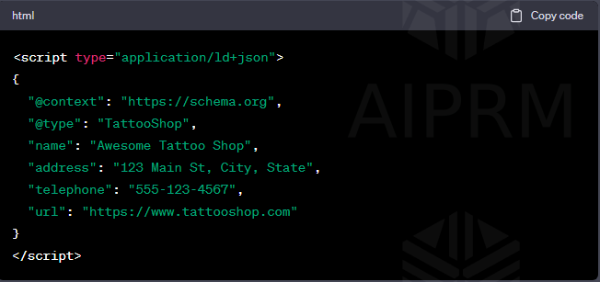

By implementing these technical SEO practices, the Tattoo Shop can enhance its online visibility, attract more organic traffic, and potentially gain a competitive advantage in the online market. Remember that technical SEO is just one aspect of a comprehensive SEO strategy, and other factors like content quality, backlinks, and user experience also play significant roles in achieving success in search engine rankings.

Read more at:
https://www.semrush.com/blog/technical-seo/

Semrush



How to Use SEMrush for a Tattoo Shop - Step-by-Step Guide

SEMrush is a powerful digital marketing tool that can help tattoo shops improve their online visibility, target the right audience, and boost their website traffic. Here's a step-by-step guide on how to use SEMrush for a tattoo shop with practical examples:

Step 1: Sign Up and Set Up Your SEMrush Account

Go to the SEMrush website and sign up for an account. You can choose from different plans, including a free trial.

After signing up, log in to your SEMrush account and set up your project. Click on "Add New Project" and enter your website's domain, such as www.exampletattooshop.com. Choose the appropriate country and device type (desktop or mobile) for your target audience.

Step 2: Conduct a Keyword Research for Tattoo-related Terms

In your SEMrush dashboard, navigate to "Keyword Analytics" and select "Keyword Magic Tool."

Enter relevant keywords related to tattoo shops, such as "tattoo studio," "tattoo artist," "best tattoo parlor," etc.

SEMrush will provide you with a list of related keywords along with their search volume, competition, and other important metrics. Aim for keywords with a balance of search volume and manageable competition.

Step 3: Analyze Competitors

Identify your main competitors in the tattoo industry. Use SEMrush's "Organic Research" or "Competitive Research" features to find them.
Analyze their organic keywords, backlinks, and top-performing content to understand their strategies.

Learn from your competitors' successful tactics and tailor them to fit your tattoo shop's unique brand and offerings.

Step 4: Optimize On-Page SEO

Use the keywords you researched earlier to optimize your website's content. Ensure your main pages, like homepage, services, and about us, contain relevant keywords.

Create valuable blog posts on tattoo-related topics using the identified keywords to attract organic traffic and establish yourself as an industry authority.

Step 5: Track Your Rankings

Monitor your website's search engine rankings for the targeted keywords. In SEMrush, go to "Position Tracking" and add the selected keywords to track their performance over time.

Regularly analyze the ranking changes to identify opportunities for improvement or content gaps.

Step 6: Local SEO Optimization

If you have a physical tattoo shop, focus on local SEO to attract customers in your area.

Use SEMrush's "Local SEO" features to audit your NAP (Name, Address, Phone) consistency across online directories and update them if necessary.

Encourage customers to leave positive reviews on Google My Business and other relevant review platforms.

Step 7: Backlink Analysis

Backlinks are crucial for SEO success. Use SEMrush's "Backlink Analytics" to identify websites linking to your competitors.

Reach out to relevant websites in the tattoo or art niche to request backlinks to your website. These high-quality backlinks can boost your website's authority.

Step 8: Social Media and Content Marketing

Use SEMrush's "Social Media Tracker" to monitor your social media performance and that of your competitors.

Plan and schedule engaging content across social media platforms to build a loyal following and drive traffic to your website.

Step 9: Paid Advertising (Optional)

Consider using SEMrush's "Advertising Research" to analyze your competitors' paid advertising strategies.

If you have a budget for paid advertising, run targeted campaigns on platforms like Google Ads and Facebook Ads to promote your tattoo shop.

Step 10: Monitor and Adapt

Regularly review your SEMrush reports and analytics to measure your progress.

Based on the insights gained, adapt your strategies to improve your online presence continually.

Example Scenario:

Suppose your tattoo shop is located in New York City, and you've used SEMrush to find the top keywords related to tattoo shops in NYC. You've optimized your website with relevant keywords and started publishing blog posts on tattoo trends and aftercare tips. Additionally, you've used SEMrush to analyze your main competitors and found that some of them are getting traffic from backlinks on local art blogs.

In response to this, you reach out to some local art bloggers and collaborate on a guest post that highlights the tattoo artistry in New York City, featuring your shop as a prominent example. This collaboration leads to several high-quality backlinks to your website and increases your organic traffic significantly. Furthermore, you've been tracking your keyword rankings through SEMrush and notice improvements in your website's search engine positions for targeted tattoo-related keywords.

By consistently utilizing SEMrush and adapting your strategies based on the insights gained, your tattoo shop's online visibility and traffic continue to grow, attracting more potential customers to your studio.

Remember, SEMrush is a comprehensive tool with numerous features, so take your time to explore and make the most of its capabilities to benefit your tattoo shop's digital marketing efforts.

See Live Example -

- Backlinks increased by: +11%
- Referring Domain increased by: +14%
- Live update: 32 Backlinks found in the last 24 hrs.

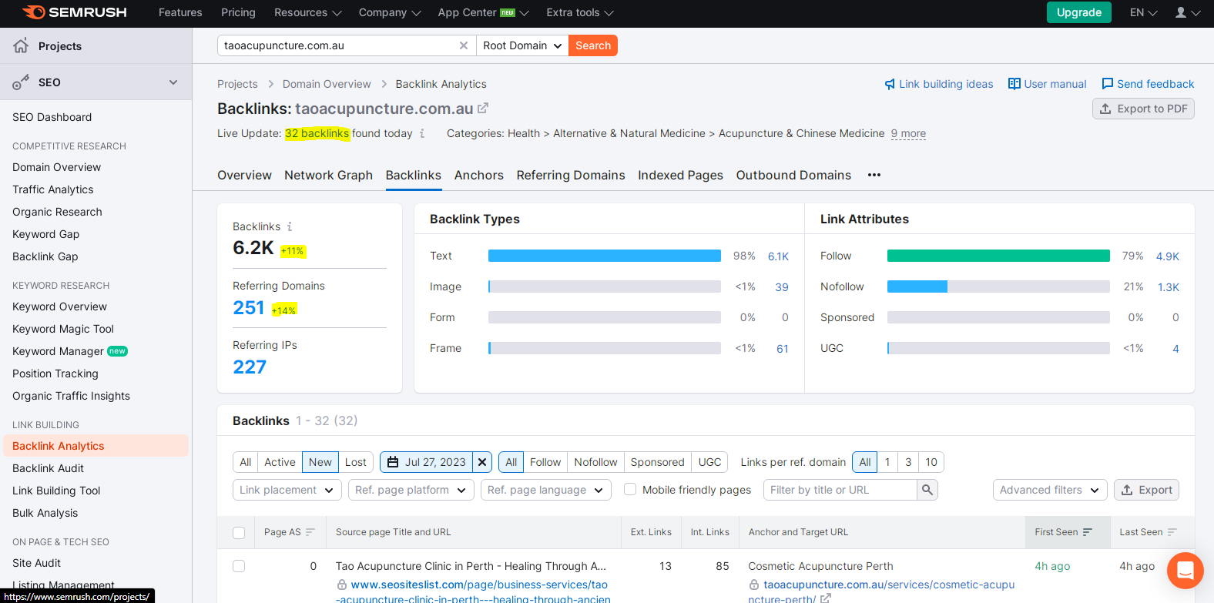

Read more at:
https://www.semrush.com/blog/semrush-getting-started-guide/

Google Analytics



Google Analytics is a powerful web analytics tool that can provide valuable insights into the performance of your website and help you make data-driven decisions for your tattoo shop. By using Google Analytics, you can track various metrics such as website traffic, user behavior, and marketing performance. In this guide, we'll walk you through the process of setting up Google Analytics for your tattoo shop and demonstrate how to interpret the data with an example.

Step 1: Sign Up for a Google Analytics Account

Go to the Google Analytics website (analytics.google.com) and sign in using your Google account or create one if you don't have it.
Click on the "Start Measuring" button and follow the setup process to create a new property for your tattoo shop's website.

Step 2: Install Google Analytics Tracking Code

Once your property is created, you'll receive a tracking code snippet.
Copy the provided tracking code and paste it into the <head> section of your website's HTML code. This code allows Google Analytics to collect data from your website.

Example:

Let's say you own a tattoo shop called "InkMaster Tattoo Studio," and your website URL is www.inkmastertattoo.com. You've signed up for a Google Analytics account and received the tracking code snippet. Now, you need to integrate the code into your website. Open your website's HTML code, find the <head> section, and paste the tracking code just before the closing </head> tag.

Step 3: Set Up Goals and E-commerce Tracking

Define goals that align with your tattoo shop's objectives. For example, you might want to track the number of appointment bookings, contact form submissions, or newsletter sign-ups.

To set up goals, go to your Google Analytics account, select your property, and navigate to the "Admin" section. Under "View," click on "Goals" and create a new goal with the desired details.

If your tattoo shop sells products online, enable e-commerce tracking to monitor sales performance. This requires additional configuration in Google Analytics and your e-commerce platform.

Step 4: Explore Google Analytics Reports

After installing the tracking code and setting up goals, Google Analytics will start collecting data.

Visit your Google Analytics account, select your property, and explore the various reports available.

The "Audience" report will provide insights into your website's visitors, such as demographics, interests, and location.

The "Acquisition" report will show you how users are finding your website, whether through organic search, social media, or referral sources.

The "Behavior" report will give you details about the content on your website and how users interact with it.

The "Conversions" report will track goal completions, providing data on how well your tattoo shop's website is performing in terms of achieving its objectives.

Example:

In the case of InkMaster Tattoo Studio, you can use Google Analytics to determine the number of website visitors who book an appointment (goal conversion) and the traffic sources that bring the most potential customers to your website. This data can help you evaluate the effectiveness of your marketing efforts and optimize your website to improve conversion rates.

Conclusion:

Google Analytics is a powerful tool for understanding your tattoo shop's online performance. By setting up and using it effectively, you can gain valuable insights to enhance your website, marketing strategies, and overall business success. Regularly analyze the data, make informed decisions, and continually refine your online presence to attract more customers to your tattoo shop.

See live Example:

Always check your referral traffic of last month and again create on the same sites. It can help in improving traffic.
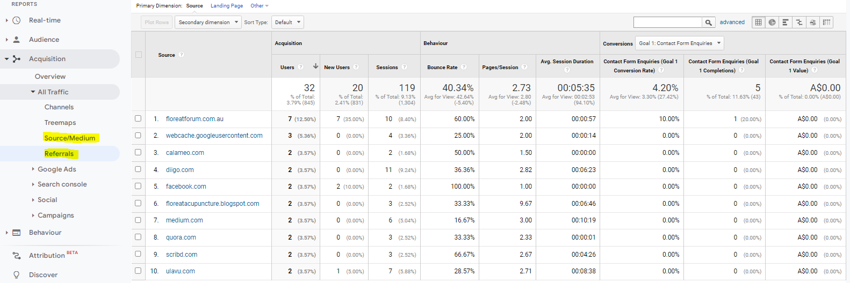

Read more at:
https://analytics.google.com/analytics/academy/course/6

Google Search Console
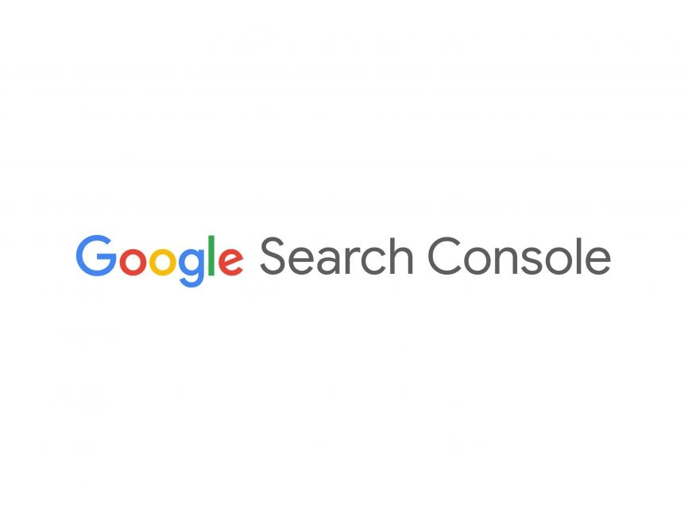

Google Search Console is a powerful tool that can help your tattoo shop improve its online presence and visibility in Google search results. By using this free service provided by Google, you can gain valuable insights into your website's performance, identify and fix issues, and optimize your online content to attract more potential customers. In this guide, we'll walk you through the process of setting up and using Google Search Console, using an example of a fictional tattoo shop called "InkMaster Tattoos."

Step 1: Set Up Google Search Console

Go to Google Search Console:

Visit the Google Search Console website (https://search.google.com/search-console) and sign in with your Google account. If you don't have a Google account, you'll need to create one.

Add Your Website:

Click on the "Add Property" button and enter your tattoo shop's website URL (e.g., www.inkmastertattoos.com). Follow the on-screen instructions to verify your ownership of the website. Google provides various verification methods, such as adding an HTML tag to your website or using Google Analytics.

Step 2: Explore the Dashboard

After successful verification, you'll be taken to the Google Search Console dashboard. Here, you can find valuable information about your website's performance, including search queries, impressions, clicks, and more.

Review the Performance Report:

Click on "Performance" in the left sidebar to see how your website performs in Google search. You can set the date range to see data for a specific time frame. The report will show you the total clicks, impressions, click-through rate (CTR), and average position for your website's pages.

Step 3: Optimize Your Website

Analyze Search Queries:

In the Performance report, you can see the search queries that led to clicks on your website. Identify the keywords that are driving traffic to your site and those with high impressions but low clicks. Optimize your content for these keywords to improve CTR.

Improve Title Tags and Meta Descriptions:

Ensure that your website's title tags and meta descriptions accurately describe your tattoo shop's services and are compelling enough to encourage clicks from search results.

Submit a Sitemap:

Create an XML sitemap of your website and submit it through Google Search Console. A sitemap helps search engines understand the structure of your site and index your pages more efficiently.

Step 4: Monitor and Fix Issues

Use the Coverage Report:

Check the "Coverage" section in Google Search Console to identify any indexing issues or errors on your website. Google will provide details about pages that couldn't be indexed and the reasons behind it.

Resolve Errors:

If any issues are detected, take necessary actions to fix them promptly. This might involve correcting broken links, resolving server errors, or improving the website's overall technical performance.

Step 5: Track Progress and Refine Strategies

Set Up Goals and Conversion Tracking:

Define specific goals for your website, such as online tattoo bookings or newsletter sign-ups. Use Google Analytics to track these conversions and assess the success of your digital marketing efforts.

Regularly Monitor Data:

Consistently analyze the data in Google Search Console to understand trends, spot opportunities, and identify areas that need improvement. This will help you refine your SEO and content strategies over time.

Conclusion:

By utilizing Google Search Console effectively, your tattoo shop, like "InkMaster Tattoos," can gain a competitive edge in the digital landscape. Monitoring performance, fixing issues, and optimizing your website will lead to increased visibility and attract more potential clients to your shop. Stay committed to refining your strategies based on the insights provided by Google Search Console to achieve long-term success in the online world.

Read more at:
https://developers.google.com/search/docs/monitor-debug/search-console-start

